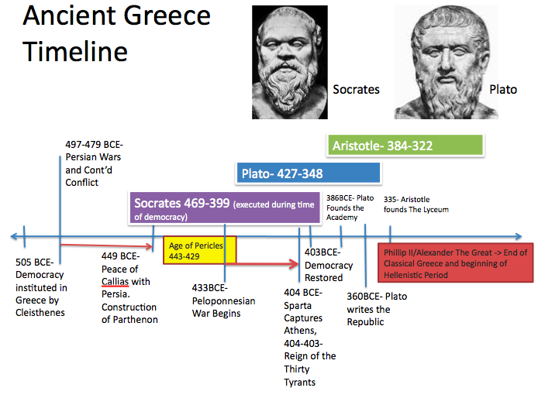

GUIDED NOTES: THE SOCRATIC METHOD

ENDURING UNDERSTANDINGS AND ESSENTIAL QUESTIONS
—How can we use questions to challenge a belief or argument?
—When we form a challenge against a belief or rule questions can help direct and organize our argument
—We can use questions to strengthen an argument or belief
—Socrates development of the elenchus (Socratic method) is one effective method of questioning that continues to be used in the Western World

ATHENS GOLDEN AGE:

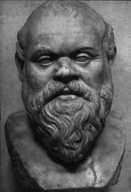

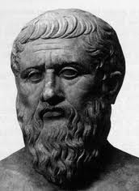

SOCRATES PLATO

THE SOCRATIC METHOD OR ELENCHUS

QUESTIONS FROM THE VIDEO CLIP

What is the Socratic Problem?

What is Socrates contribution to philosophy?

What is the question in the dialogue?

What is Socrates higher standard for truth?

OUR CLASS’S MODERN SOCRATIC DIALOUGUES

-You will be grouped in pairs
-Each pair will receive an envelop with two statements (one modern and one universal)

-For each statement
1) Choose who will be Socrates and who will be the interviewee (come up with a fun name)
2) Practice a Socratic Dialogue. The interviewee will defend the statement and Socrates will question the statement

-Write the Socratic Dialogue
1) Now that you have practiced. Write down your dialogue and refine the questions and answers
2) Be prepared to act out your dialogue in front of the class

*For the second statement switch roles

