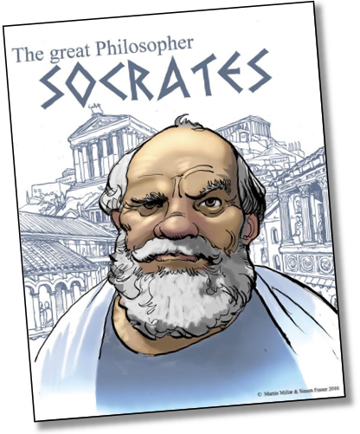
NAME: Socrates

AGE: 70

RACE: White

CITY-STATE of ORIGIN: Athens

OCCUPATION: Father of Western Philosophy, all-around annoying gad-fly

ACCUSED OF:
1) Impiety, speaking against the gods of Greece
2) Corrupting the Youth of Athens

ACCUSERS:
1) Meletus: An unknown poet of Athens, not very quick-witted. We don’t know what his motivations were
2) Anytus: Rich and influential democrat. Anytus and Socrates may haven both been romantically involved with one of Socrates’ students, Alcibiades (possibly love triangle here)
3) Lycon: Famous speaker. His son may have been a student of Socrates

EVIDENCE AVAILABLE:
- The Apology Summary: Plato’s account of the original trial
- Interview with Trial of Socrates expert, I.F. Stone

Your Mission:
The Prosecution Team- Develop an argument for why Socrates should be convicted of his crimes and be put to death
Socrates’ Defense Team- Develop an argument for why Socrates is innocent and should be cleared of all charges
Jurors Team: Understand both sides of the argument and be prepared to ask both teams questions. You will eventually decide the case and explain your decision.

